

**Graphics Programming Documentation**

|  |  |
| --- | --- |
| **Module Name:** | Graphics Programming |
| **Module Code:** | M3I625657 |
| **Module Leader:** | Bryan Young |
|  |  |
| **Student ID:** | S1920423 |
| **Student Name: Year:** | Harry Calwell 2022 |

**By submitting this assignment, I agree to following statement:**

“Except where stated explicitly, all work in this report, project and accompanying source code, is my own original work and has not been submitted elsewhere in the fulfilment of the requirement of this or any other award”

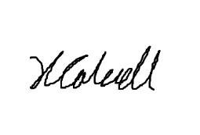  
**Signed:**

**Date:** 08/05/2022

**GitHub link:** <https://github.com/maryqueenofpox/graphics>

Contents

2 Introduction 3

3 Contextual Review and Research 3

4 Proposed Research/Development 3

5 Ethical Considerations and Professional Issues 3

6 References 3

**Figures:**

# Introduction

The additional graphical technique for this project is the “customShader” class within the build; an inheritance of the Shader.h script which calls the “customShader.frag” and “customShader.vert” scripts to act as the fragment shading and vertex shading respectively. The goal of the shader is to give a textured object a lighting effect that will darken the object and its hue when it is far away from a light source but then increase hue, brightness, and ambient lighting as it gets closer to the light source then at a set distance the object will begin to restore its texture’s original colours. This is to give game objects a readable perspective of distance from light. Listed below are three figures that show how an object will look when it is far from light source, middle distance to light source, and close to light source. The light source for this scene is set to the camera’s position but can be mapped to any game object’s position.

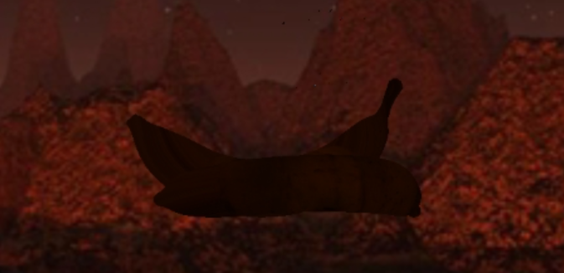  
*Figure 1*: Banana mesh far from light source. The texture’s colour is completely removed as the model’s hue is shadowed to a dark-orange hue.  
  
*Figure 2*: Banana mesh is middle-distance from light source. The texture’s colour is beginning to reappear as the rest of the model’s hue is gradually increased to a brighter orange colour.

*Figure 3*: Banana mesh is close to light source. The texture’s colour is restored.

# Contextual Review and Research

# Proposed Research/Development

# Ethical Considerations and Professional Issues

# References